Example #1 Dynamic modeling of abundance of interacting species over time.

Consider interactions between species i and species j observed at time intervals k. For the simplicity of the example, we just show one set of interactions, but this could be generalized to any number of interacting species pairs.

Static

The simplest equation to describe the observed intensity of interactions (Y) is

$$Y_{i,j,k}∼Poisson(λ_{i,j})$$

In this model each temporal observation stems from the same underlying interaction intensity among pairs of species, with each temporal network a realization of this underlying relationship. The variation among sampling periods is purely due sampling constraints.

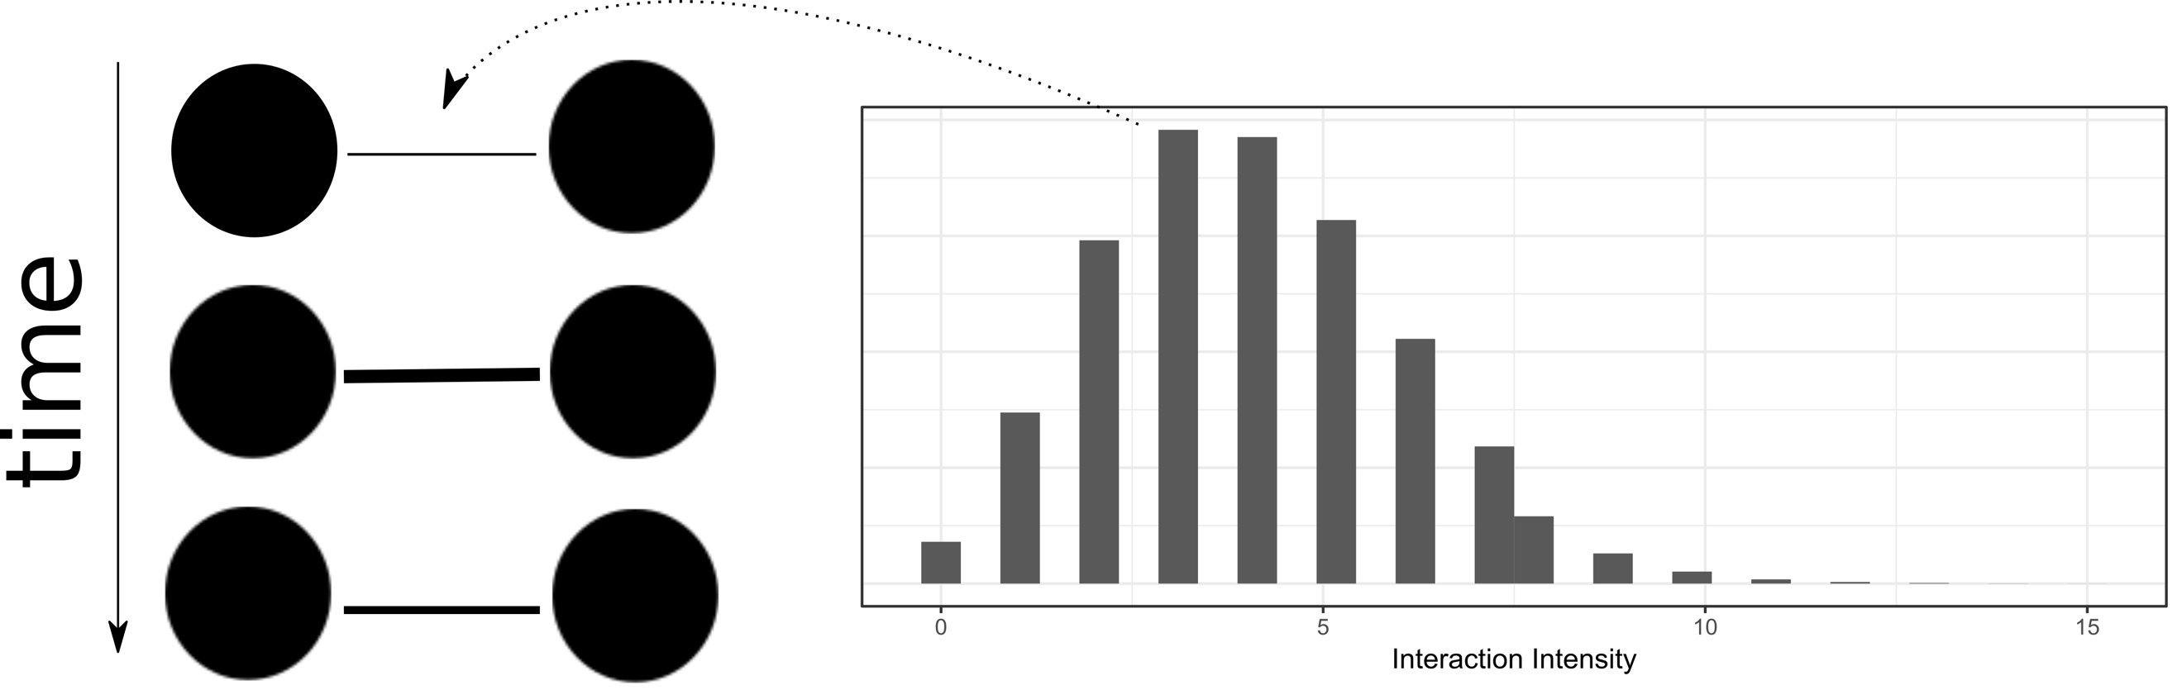

To incorporate temporally variable interactions, we could change equation 1 to

$$Y_{i,j,k}∼Poisson(λ_{i,j,k})$$

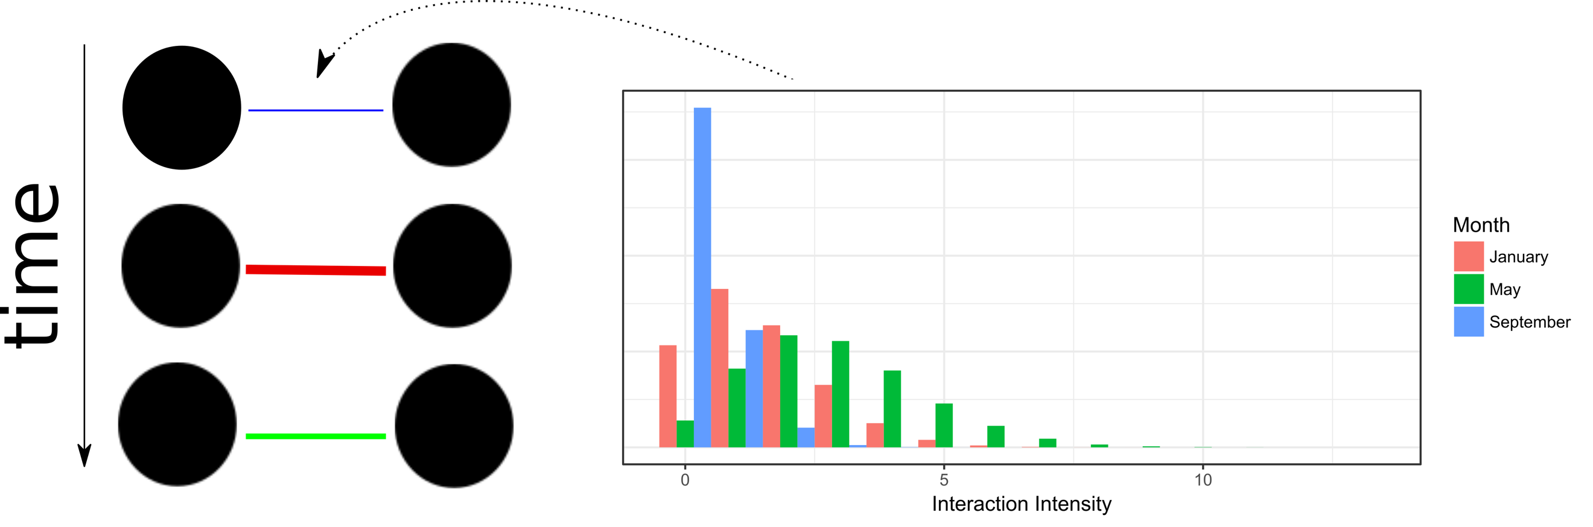

To specify predictors of interaction betadiversity, one option is to model the mean interaction intensity per month as a function of temporally variable abundance of one, or both, species.

$$Y_{i,j,k}∼Poisson(λ_{i,j,k})$$

$$\log\left(λ_{i,j,k}\right)=α_{i,j}+β*Abundance_{i,k}$$

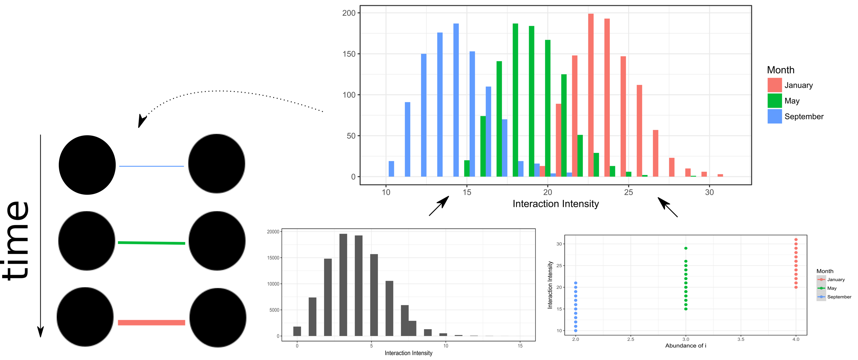

Example #2 Dynamic modeling of trait-match of interacting species over space.

To predict the intensity of interacting partners across space, we can use a similar framework to example 1. Here the interaction intensity is a function of the similarity in morphological traits among changing partners.

$$Y_{i,j,k}∼Poisson(λ_{i,j,k})$$

$$\log\left(λ_{i,j,k}\right)=α_{i}+β*\left|Trait_{i}-Trait_{j}\right|$$

